Weekly Agenda 10/10 – 10/13
Brit Lit and Comp – McBride
Mon. 10 – Lower LMC - Laptops
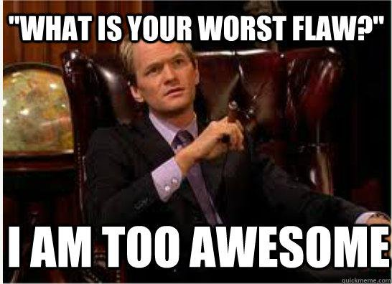
- Write Resumes
- HW – Work on Resumes
Tues. 11
- Tune Tuesday
- Fine Tune Resumes
- Assemble into interview Committees
  - What are you looking for?
- HW – Finish resume for interview on Friday!
Wed 12 – No School – Yom Kippur
- HW – Have finalized, anonymous resume ready to present to your employer/admissions officer!
Thurs. 13- Shortened periods - Conferences
- Interview Time! Squad up!!
- Independent book research
- HW – Enjoy your day off tomorrow! Find an independent reading book for 2nd quarter!

Learning Goals:
W. 12.4 - Produce clear and coherent writing in which the development, organization, and style are appropriate to task, purpose, and audience. (Grade-specific expectations for writing types are defined in standards 1-3 above.)
W.12.5 - Develop and strengthen writing as needed by planning, revising, editing, rewriting, or trying a new approach, focusing on addressing what is most significant for a specific purpose and audience. (Editing for conventions should demonstrate command of Language standards 1-3 up to and including grades 11-12 here.)

Weekly Agenda 10/10 – 10/13
Brit Lit and Comp – McBride
Mon. 10 – Lower LMC - Laptops
- Write Resumes
- HW – Work on Resumes
Tues. 11
- Tune Tuesday
- Fine Tune Resumes
- Assemble into interview Committees
  - What are you looking for?
- HW – Finish resume for interview on Friday!
Wed 12 – No School – Yom Kippur
- HW – Have finalized, anonymous resume ready to present to your employer/admissions officer!
Thurs. 13- Shortened periods - Conferences
- Interview Time! Squad up!!
- Independent book research
- HW – Enjoy your day off tomorrow! Find an independent reading book for 2nd quarter!

Learning Goals:
W. 12.4 - Produce clear and coherent writing in which the development, organization, and style are appropriate to task, purpose, and audience. (Grade-specific expectations for writing types are defined in standards 1-3 above.)
W.12.5 - Develop and strengthen writing as needed by planning, revising, editing, rewriting, or trying a new approach, focusing on addressing what is most significant for a specific purpose and audience. (Editing for conventions should demonstrate command of Language standards 1-3 up to and including grades 11-12 here.)

